### [A Pop-up Welcome Card for My New Neighbor - A Slider Card](https://papercraftetc.blogspot.com/2016/05/a-pop-up-welcome-card-for-my-new_17.html)

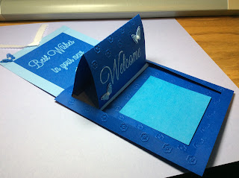

Welcome Card open.

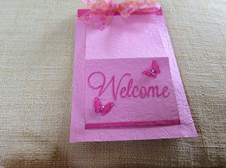

Welcome card closed.

I have a new neighbor across the street and I wanted to welcome them into the neighborhood. I made some brownies and this card with my contact information...my phone numbers and email address. This information was written on a 3 x 3 sticky note which can be removed from the card. I used cardstock for the card. This card will fit in a 5 x 7 envelope or an A7 envelope.

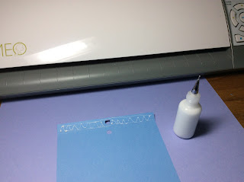

Glue the slider card tab down.

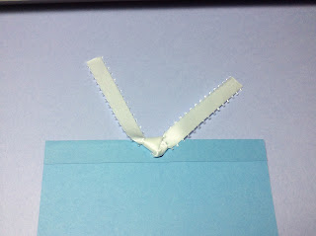

Insert a ribbon in the whole.

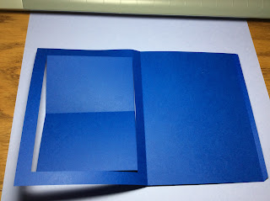

Fold the main card as shown.

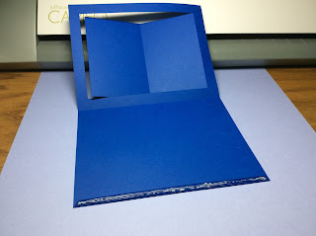

Glue the edge as shown.

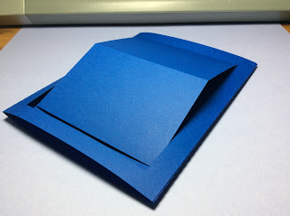

Completed main card.

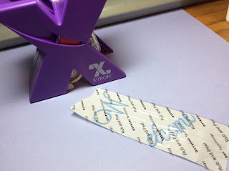

I used a Zyron sticker maker to add adhesive to the Welcome letters and attached it to the card.

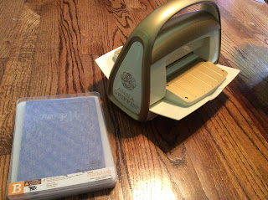

I am embossed the card with a Cuttlebug using the Simple Flower folder.

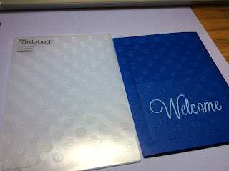

Embossed Card.

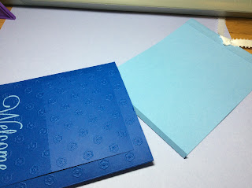

Insert the slider card with the bottom tab folded into the center of the main card.

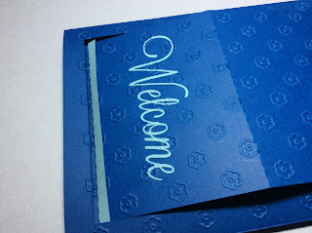

Catch the bottom edge of the main folder with the slider card.

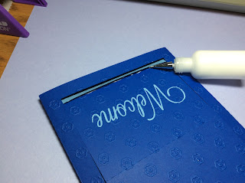

Glue the bottom edge of the slider to the main card.

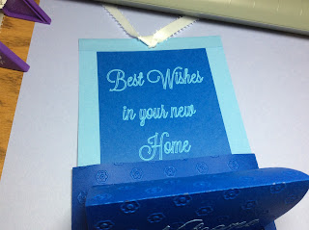

Add the greetings to the top half of the card. I used Silhouette Sketch Pens to print out the greeting.

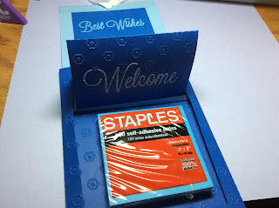

Sticky note fits perfectly in the bottom half for your personal information.

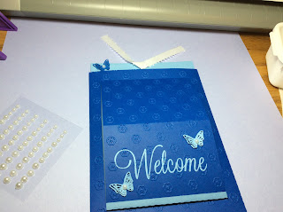

I added the butterfly embellishments and pearls to the butterfly.

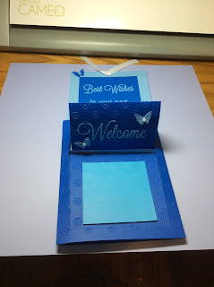

Completed card open.

Here's to new friendships...Welcome Friends!